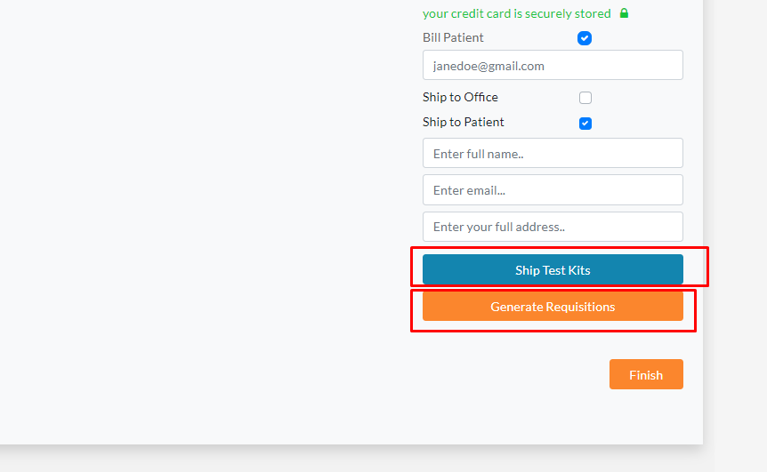

On the checkout page here we have Ship test kits and Generate Requisition??

Explain its …